***Capstone Project Week 5; Finding the Best Location for an Italian Restaurant in Amsterdam (The Netherlands)***

*By Wineke van Lent*

**Introduction**

For an international franchise company of high quality Italian restaurants we examine what the best location is to open an Italian restaurant in Amsterdam.

Amsterdam is the capital and most populous city of the Netherlands with a population of 872,680 within the city proper, 1,558,755 in the urban area. It is an attractive town that is popular with tourists but also for families and expats due to its large International School and location near to Schiphol Airport. The city has many restaurants of all nationalities and is famous for its nightlife.

The business plan for the Italian restaurant aims to open a high quality Italian restaurant in Amsterdam with at least 70 seats. The real estate agent has provided several locations that meet the requirements of the building: at least 130 square meters for customers, at least 35 square meters for the kitchen, right permits on the building to start a restaurant.

Amsterdam has a very small market for properties, sales are going at a very fast pace. In combination with the many small and old buildings this resulted in a list of 10 suitable locations or the new Italian restaurant.

As the selected locations for the Italian restaurant are more or less comparable, the final decision for the location of the Italian restaurant will therefore be based on the neighbourhood. The new Italian restaurant wants to know the following things about the neighbourhoods of each possible location:

1. How comparable are the neighbourhoods?
2. How many competing Italian restaurant are available in these neighbourhoods?

**Data**

The following data is needed to answer the research questions.

1. Data that defines the neighbourhoods. For this we use data from the city of Amsterdam: '<https://allecijfers.nl/gemeente-overzicht/amsterdam/>'.
2. Data on the venues within each neighbourhood to make them comparable. We use data from a location data provider for this purpose. Foursquare has been selected for this project.
3. Data on competing Italian restaurants. Foursquare is used for this purpose.
4. The list of possible new locations for the Italian restaurant as provided by the real estate agent.

**Methodology**

For each research questions the methodology is described.

*Analyzing the comparability of neighbourhoods in Amsterdam*

First the neighbourhoods are defined. For this we use data from the city of Amsterdam: '<https://allecijfers.nl/gemeente-overzicht/amsterdam/>'. Webscraping within Python is used to collect actual data from this website. After collecting the data, we cleaned it by removing disturbing lines that did not contain information about neighbourhoods, added information on the latitude and longitude of each location by using Geolocator and we plotted each neighbourhood on a map of Amsterdam.

Next data on the venues in Amsterdam was needed. We used data from Foursquare for this purpose and built an API to collect real time location data on all venues in a neighbourhood.

Combing the data on the neighbourhoods and the venues is the next step. Then the information was grouped to the top 5 venues in each neighbourhood. However Amsterdam has over 400 neighbourhoods so a smarter way to measure comparability of neighbourhoods is needed.

Artificial Intelligence is used to measure the comparability of the neighbourhoods. For this particular problem K means clustering was selected because it is an unsupervised AI method, which is very suitable for our goals since we do not know the differences between all neighbourhoods. We distinguish 20 neighbourhoods out of the more than 400 neighbourhoods in Amsterdam. The final result of the neighbourhoods will be plotted on a map of Amsterdam. Also an overview of the characteristics of each cluster will be provided.

*Analyzing competing Italian restaurants in Amsterdam*

Starting point is data on the Italian restaurants in Amsterdam. This will be collected with an API on Foursquare. This data will be grouped with the earlier collected information on the Amsterdam neighbourhoods. The result of this step is an analysis of Italian restaurants in each neighbourhood of Amsterdam. Also a map of all Italian restaurants in Amsterdam is provided.

The postal codes as provided by the real estate agent will be used to select only the competing Italian restaurants near each selected location. This leads to the final result: a table of all competing Italian restaurants near each selected location.

**Results**

*Question 1: Comparison of the Neighbourhoods*

First we draw a map of the possible locations for the new Italian Restaurant. See Figure 1.

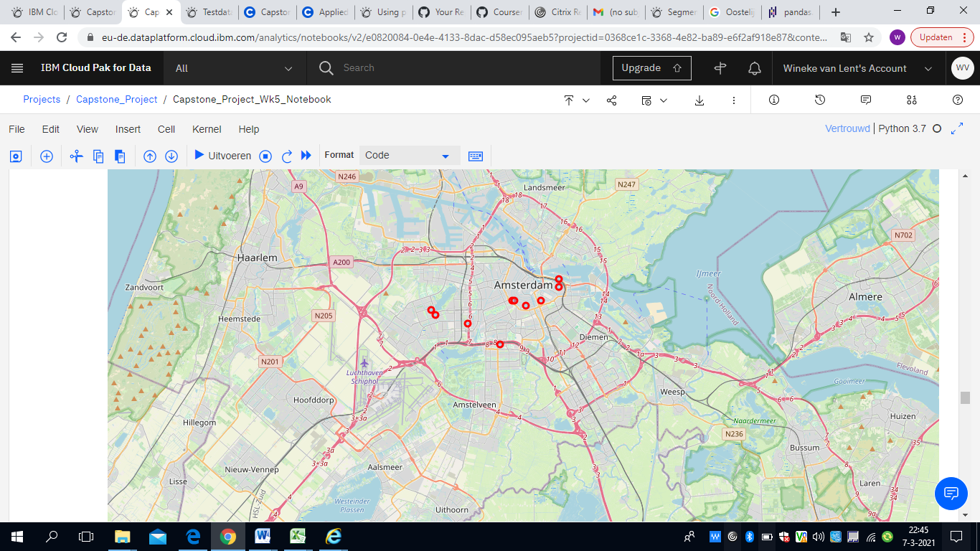

*Figure 1; Possible locations for the new Italian Restaurant visualized.*

We used K means clustering to compare the neighbourhoods in Amsterdam. The coloroured dots on the map of Figure 2 are the results, we also added the possible locations for the new restaurants in red unfilled dots.

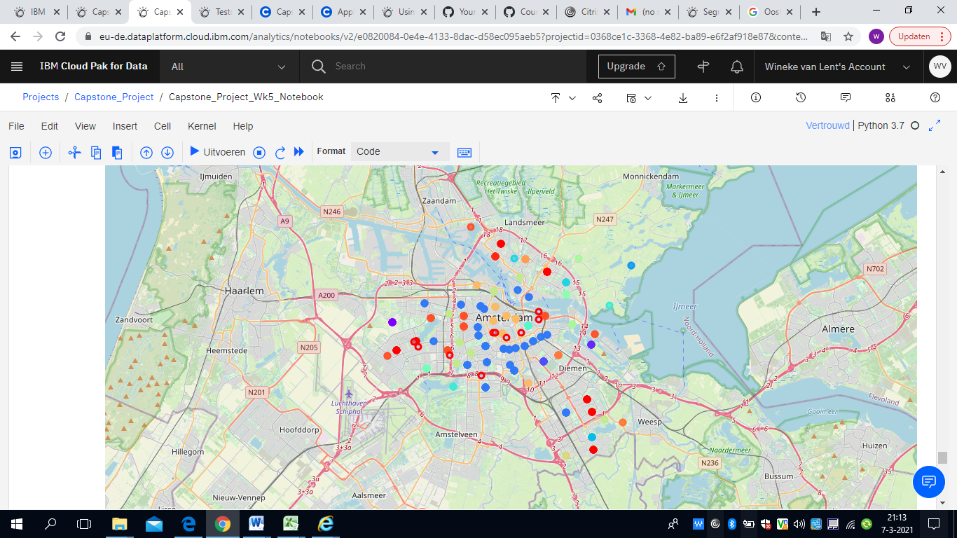

*Figure 2: Results of the K means clustering of Amsterdam neighbourhoods and in the red unfilled dots the possible locations for the Italian Restaurant*

The result of our K means clustering is a table with the possible locations and their cluster. It is summarized below. We checked the descriptions of each cluster. They can be found in appendix 1.

|  |  |  |  |  |
| --- | --- | --- | --- | --- |
| Adress | Postal Code | Cluster |  |  |
| Leidseplein 9 | 1017 PS | 15 | Amsterdam Central | Nightlife |
| Leidsekruisstraat 11 | 1017 RE | 15 | Amsterdam Central | Nightlife |
| Reguliersgracht 110 | 1017 LX | 15 | Amsterdam Central | Nightlife |
| Meer en Vaart 405 | 1068 LH | 0 | Shopping cluster | Shopping |
| Osdorpplein 1014 | 1068 TG | 0 | Shopping cluster | Shopping |
| Oostelijke Handelskade 4 | 1019 HM | 18 | Restaurant cluster | Restaurants |
| Jacob Bontiusplaats 10 | 1018 LL | 18 | Restaurant cluster | Restaurants |
| Delflandplein 22 | 1062 HR | 18 | Restaurant cluster | Restaurants |
| Roetersstraat 15 | 1018 WD | 9 | Zoo cluster | Zoo, restaurants |
| Arnold Schönberglaan 9 | 1082 MJ | 4 | Park cluster | Park, bars, restaurants |
|  |  |  |  |  |

*Table 1: Possible Italian Restaurants and their respective clusters*

*Results on the competing Italian Restaurants*

We examined the competing Italian restaurants and projected them in blue on the map in Figure 3. The possible locations for the new restaurant are presented in red.

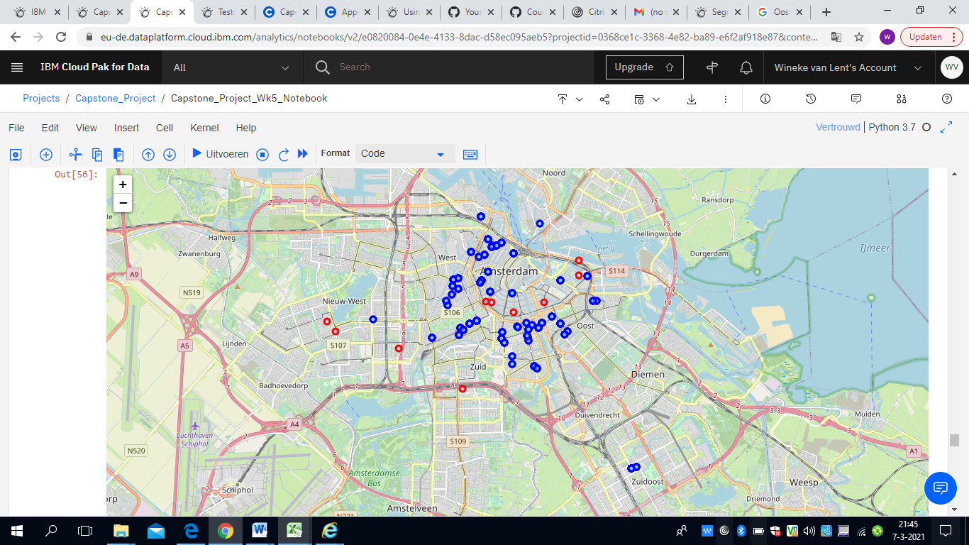

*Figure 3: Competing Italian restaurants (blue) and the possible new locations (red)*

**Discussion**

In this report we examined the best possible location for an Italian restaurant in Amsterdam based on the neighbourhood and other competing Italian Restaurants.

First we compared the neighbourhoods of 10 possible locations for a new Italian Restaurant. In Table 2 (next page) we added a classification and a description to the cluster number based on the information in Apendix 1.

Based on the customers desire for the restaurant we provided an advice on how suitable the possible location is. The customer asked for a living neighbourhood that attracts guests for a high quality dinner. + is suitable, 0 stands for neutral and – for not suitable.

Based on Table 2 the locations in cluster 15 are not recommended. It is too full of coffeeshops and nightlife. This is not the type of public for a high quality dining experience. Cluster 0 received a neutral because it is in the shopping area and it is questionable whether it would attract enough guests for the evening as the shops are closed.

So, only based on the neighbourhood comparison the locations in cluster 18, 9 and 4 seem suitable for the new Italian Restaurant.

|  |  |  |  |  |  |
| --- | --- | --- | --- | --- | --- |
| Adress | Postal Code | Cluster | Cluster classification | Cluster description | Suitable |
| Leidseplein 9 | 1017 PS | 15 | Amsterdam Central | Nightlife | - |
| Leidsekruisstraat 11 | 1017 RE | 15 | Amsterdam Central | Nightlife | - |
| Reguliersgracht 110 | 1017 LX | 15 | Amsterdam Central | Nightlife | - |
| Meer en Vaart 405 | 1068 LH | 0 | Shopping cluster | Shopping | - |
| Osdorpplein 1014 | 1068 TG | 0 | Shopping cluster | Shopping | - |
| Oostelijke Handelskade 4 | 1019 HM | 18 | Restaurant cluster | Restaurants | + |
| Jacob Bontiusplaats 10 | 1018 LL | 18 | Restaurant cluster | Restaurants | + |
| Delflandplein 22 | 1062 HR | 18 | Restaurant cluster | Restaurants | + |
| Roetersstraat 15 | 1018 WD | 9 | Zoo cluster | Zoo, restaurants | + |
| Arnold Schönberglaan 9 | 1082 MJ | 4 | Park cluster | Park, bars, restaurants | + |
|  |  |  |  |  |  |

*Table 2; The possible locations and the advice based on the neighbourhood locations*

The competition around the Italian restaurants was also examined. Figure 4 shows the results of the reduced locations (red) and the competing Italian Restaurants. 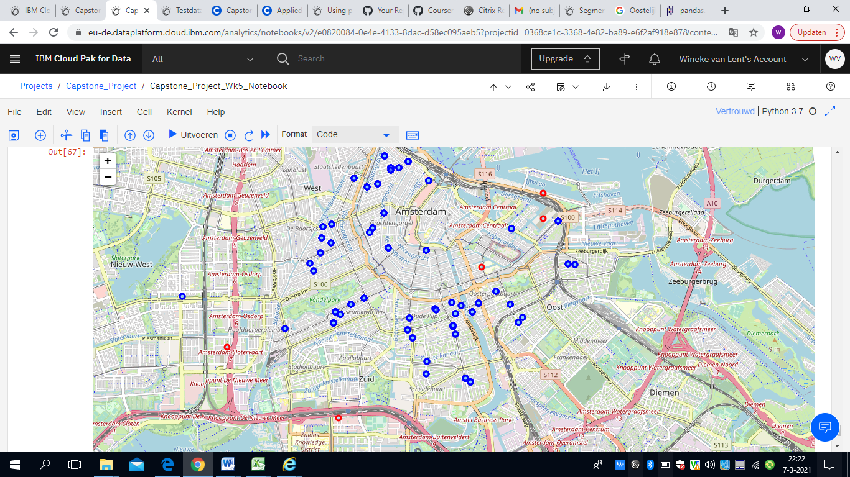

*Figure 4: Reduced possible locations (red) and the competition (blue)*

The competition does not seem to be fierce near all possible locations, so this does not seem a hard criteria to make the decision. Therefore we conclude by stating a slight preference for the other 3 locations. This is summarized in Table 3.

|  |  |  |  |  |  |  |
| --- | --- | --- | --- | --- | --- | --- |
| Adress | Postal Code | Cluster | Cluster classification | Cluster description | Suitable neighbourhood | Suitable based on competition |
| Oostelijke Handelskade 4 | 1019 HM | 18 | Restaurant cluster | Restaurants | + | 0 |
| Jacob Bontiusplaats 10 | 1018 LL | 18 | Restaurant cluster | Restaurants | + | 0 |
| Delflandplein 22 | 1062 HR | 18 | Restaurant cluster | Restaurants | + | + |
| Roetersstraat 15 | 1018 WD | 9 | Zoo cluster | Zoo, restaurants | + | + |
| Arnold Schönberglaan 9 | 1082 MJ | 4 | Park cluster | Park, bars, restaurants | + | + |
|  |  |  |  |  |  |  |

*Table 3: Final recommendation for the possible locations*

**Conclusion**

In this report we examined the best possible location for an Italian restaurant in Amsterdam. Based on our neighbourhood comparison we recommended 5 possible locations. Based on an analysis of the competition 3 out of the 5 remaining locations have a slight preference. We recommend the customer to make the final decision based on the location itself: square meters and the pricing.

**Reference to Github: https://github.com/Winekevl/Coursera_Capstone/blob/master/Capstone_Project_Wk5_Notebook.ipynb**

**Appendix 1: Detailed information about the clusters with the Italian Restaurants**

*Cluster 0; The shopping cluster*

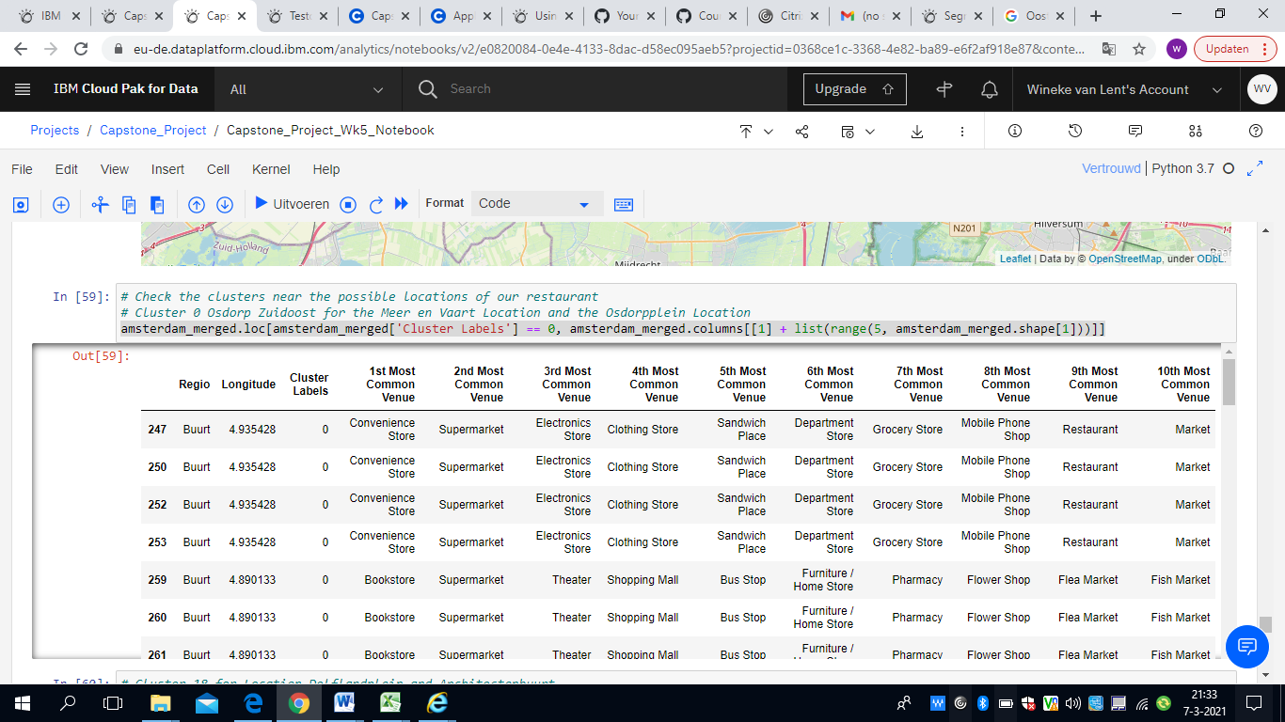

*Cluster 18; The Restaurant Cluster*

| **Regio** | **Longitude** | **Cluster Labels** | **1st Most Common Venue** | **2nd Most Common Venue** | **3rd Most Common Venue** | **4th Most Common Venue** | **5th Most Common Venue** | **6th Most Common Venue** | **7th Most Common Venue** | **8th Most Common Venue** | **9th Most Common Venue** | **10th Most Common Venue** |
| --- | --- | --- | --- | --- | --- | --- | --- | --- | --- | --- | --- | --- |
| **61** | Buurt | 4.933626 | 18 | Restaurant | Café | Deli / Bodega | Chinese Restaurant | Gastropub | Coffee Shop | Furniture / Home Store | Fish Market | Hotel | Flower Shop |
| **135** | Buurt | 4.933626 | 18 | Restaurant | Café | Deli / Bodega | Chinese Restaurant | Gastropub | Coffee Shop | Furniture / Home Store | Fish Market | Hotel | Flower Shop |
| **136** | Buurt | 4.933626 | 18 | Restaurant | Café | Deli / Bodega | Chinese Restaurant | Gastropub | Coffee Shop | Furniture / Home Store | Fish Market | Hotel | Flower Shop |
| **137** | Buurt | 4.933626 | 18 | Restaurant | Café | Deli / Bodega | Chinese Restaurant | Gastropub | Coffee Shop | Furniture / Home Store | Fish Market | Hotel | Flower Shop |
| **138** | Buurt | 4.933626 | 18 | Restaurant | Café | Deli / Bodega | Chinese Restaurant | Gastropub | Coffee Shop | Furniture / Home Store | Fish Market | Hotel | Flower Shop |
| **139** | Buurt | 4.933626 | 18 | Restaurant | Café | Deli / Bodega | Chinese Restaurant | Gastropub | Coffee Shop | Furniture / Home Store | Fish Market | Hotel | Flower Shop |

*Cluster 4: Bars, restaurants*

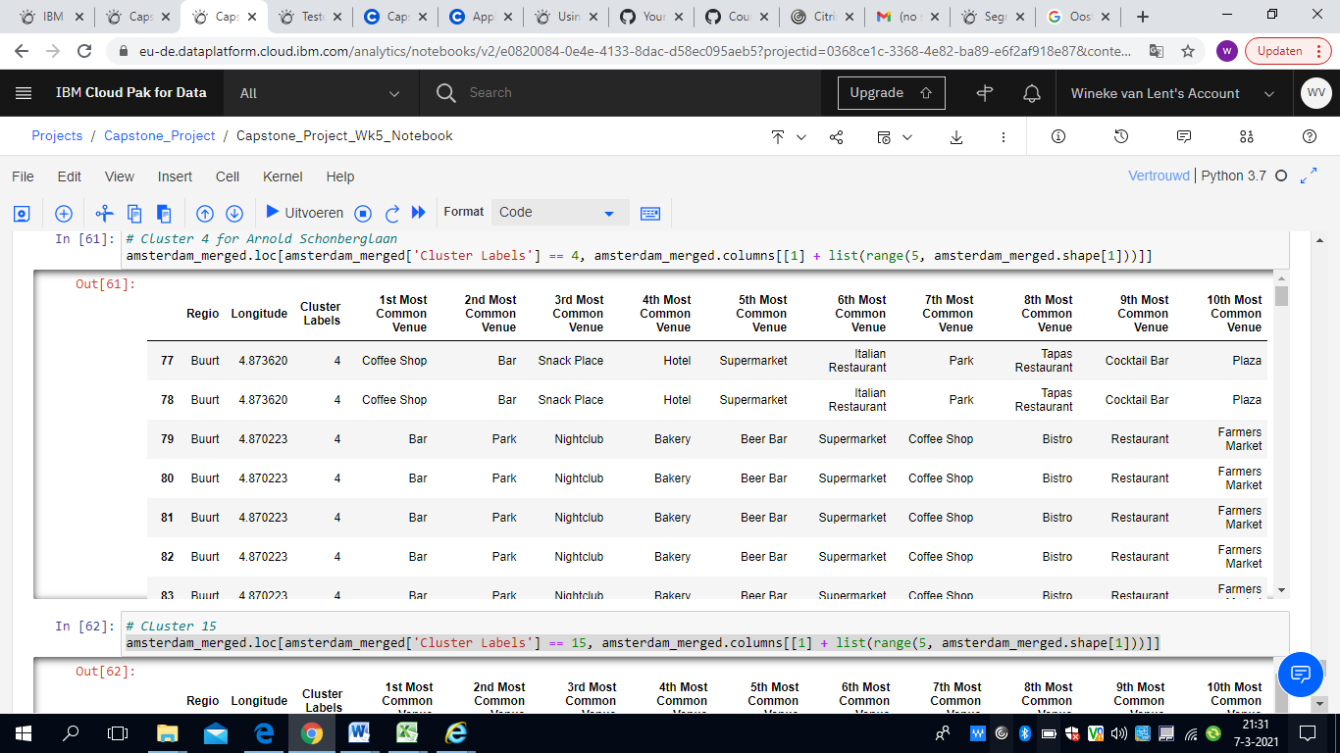

*Cluster 15; Central Amsterdam with hotels, coffeeshops, bars,*

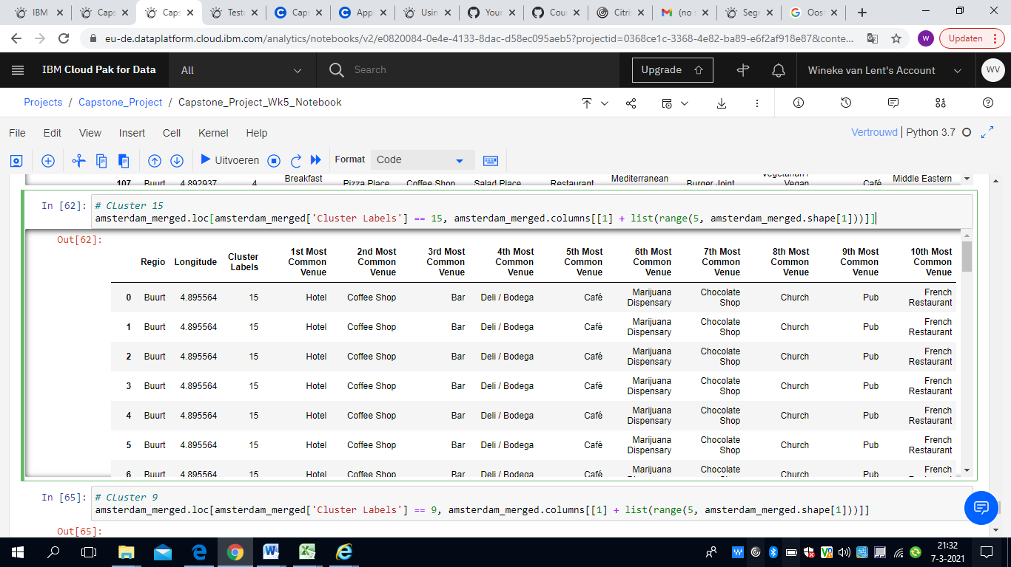

*Cluster 9 The Zoo cluster*

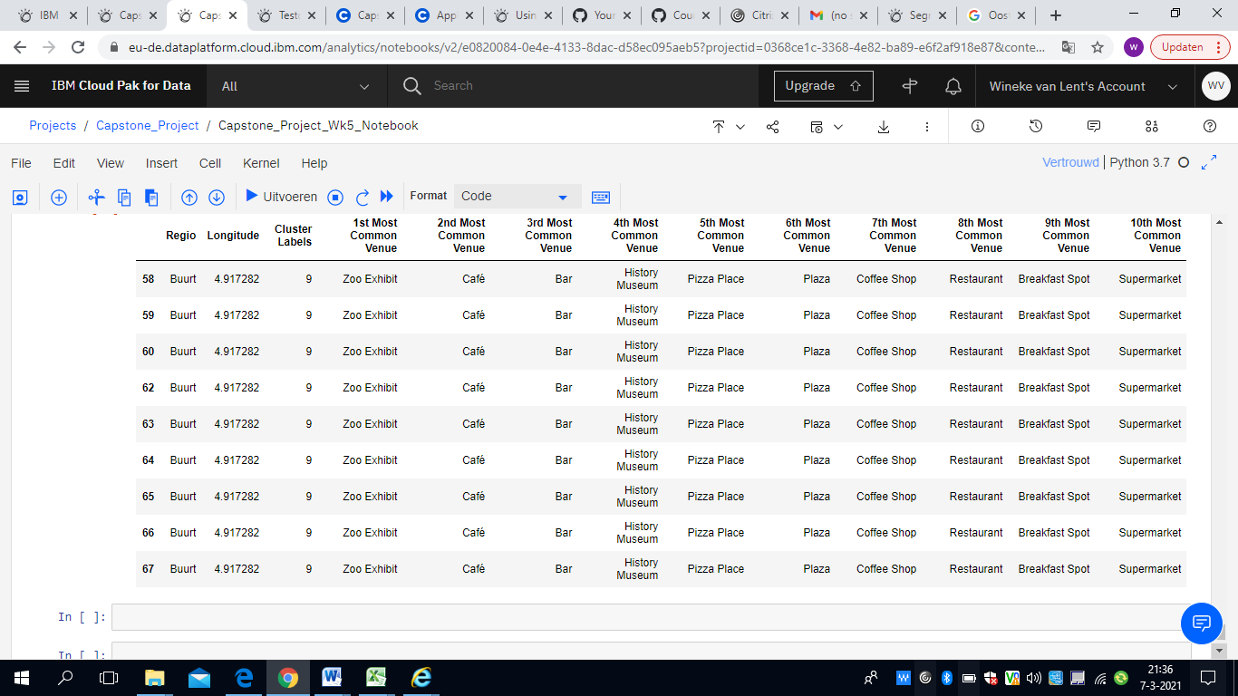

*Cluster 4; Park cluster*

